

Year 10 Science
Topic Test
Task 3

2018

Name :

Mark: /42

- You travel 370 km west to a friends house. You left at 10 am and arrived at 3 pm. What was your average velocity?
(3 marks)
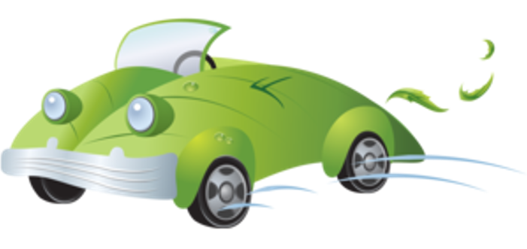

- A motor bike travels at 30 km/hr, if it travels at this speed for 30 minutes what distance will it have travelled kilometres and metres?
(3 marks)
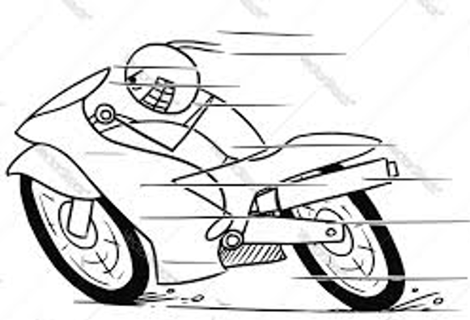

- A swimmer speeds up from 1.1 m/s to 1.3 m/s during the last 20 seconds. What was the swimmers acceleration?
(3 marks)


- Jane watches her twin sister Julie disappear over the horizon in a high powered space ship which travels at 290 000 000 m/s into deep space. Julie’s watch shows she has been gone 45 minutes, however Jane think otherwise. Calculate how long Jane has waited for the return of her sister.
(3 marks)
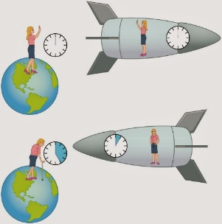

- In the year 2075 James leaves the moon in his space ship the Millennium Falcon on his way back to earth for his weekend break. Prior to departing for earth James rings his wife to lets her know he is on his way home. James sets the speed of the Millennium Falcon to 299 000 000 m/s. His wife observes him landing in the front garden 45 minutes after she received his call. How long does James think it took him to get home?
(3 marks)


- During the summer holidays, you decide to visit an amusement park. You want to ride the Ferris wheel, which has seats on the rim of a circle with a radius of 25 m. The Ferris wheel rotates at a constant speed completing 3 rotations every minute.

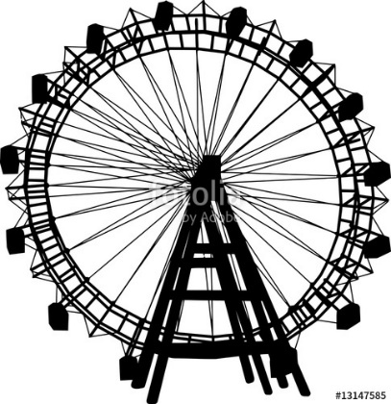
- How fast is the Ferris wheel travelling in its circular pathway?
(3 marks)

- Use your results to determine the circular acceleration of the Ferris Wheel.
(2 marks)

- A student attempts to spin a rubber a stopper (mass = 50 grams) ina horizontal circle with a radius of 75 cm. If the stopper completes 2 revolutions each second.
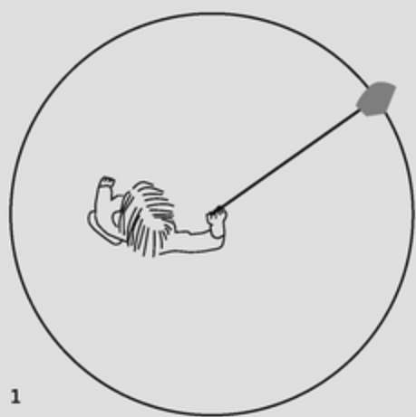
- Determine the Centripetal acceleration.
(4 marks)

- What is the force required to keep the stopper moving a circle?
(2 marks)

- A large crate of mass 250 kg is suspended 20 metres above the ground. If the rope holding the crate breaks, what will be the kinetic energy of the crate just before it hits the ground.
(3 marks)
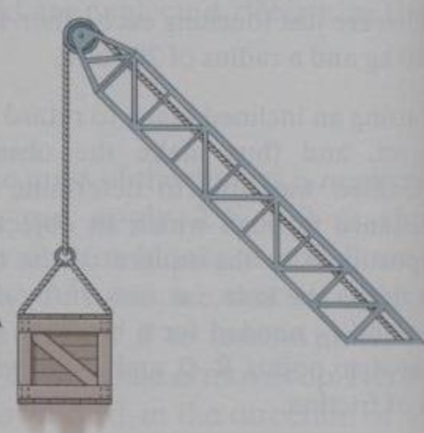

- How much energy would be required to lift 15 shot put balls 1.5 metres to the top shelf of the sports shed if each ball has a mass of 5 kg.
(3 marks)
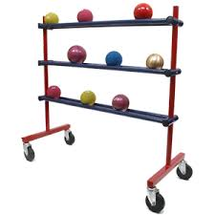

- A 1000 kg car loses 32000 joules of energy when it crashes into a brick wall. Determine how fast the car was travelling just before impact.

(3 marks)
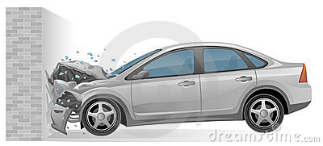

- A bullet of mass 80 grams is fired at 130 m/s at a plaster wall through which it pierces and emerges on the other side at a reduced speed of 50 m/s. How much energy was lost by the bullet as it pierced through the wall?
(4 marks)
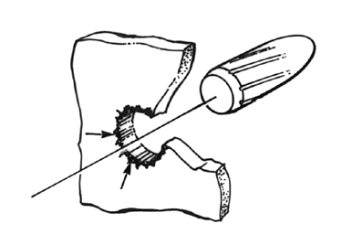

- Dan drops a stone down a well and sees it hit the water some 465 cm below.
(3 marks)
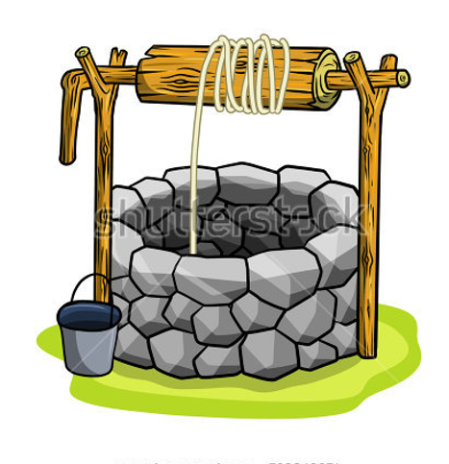

Determine the speed of the rock at the moment of impact with the water at the bottom of the well.

End of Topic Test.

